Chapter 10, Solution 49.

Using source transformation, find i in the circuit of Fig. 10.94.

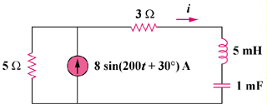

Figure 10.94
For Prob. 10.49.

Solution

After transforming the current source, the circuit becomes that shown in the figure below.

I

j

-j5

5

4030 V
+

3

- [4.472sin(200t+56.56)] A

4.472 sin(200t + 56.56°) A

